Electricity - 06
CLASS 10 - SCIENCE

 | Section A
1 | The positions of the pointer of the two ammeters A$​_{1}$ and A $​_{2}$ , and two voltmeters V $​_{1}$ and V $​_{2}$ available in the laboratory are shown in the given figure. For an experiment to study the dependence of the current on the potential difference across a resistor, the student would prefer 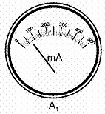  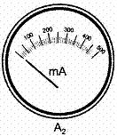  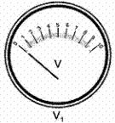  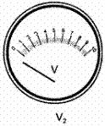  a) ammeter A$​_{2}$ and voltmeter V $​_{1}$  b) ammeter A$​_{2}$ and voltmeter V $​_{2}$  c) ammeter A$​_{1}$ and voltmeter V $​_{1}$  d) ammeter A$​_{1}$ and voltmeter V $​_{2}$ | [1]
2 | The correct set up for determining the equivalent resistance of two resistors R$​_{1}$ and R $​_{2}$ when connected in parallel is 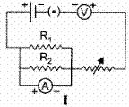  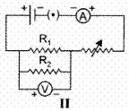  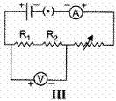  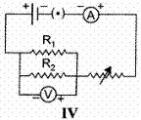  a) I  b) III  c) IV  d) II | [1]
3 | Ramesh connects three resistors as shown below to find the equivalent resistance in series. The value measured by him should be close to 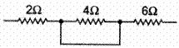  a) 12 Ω  b) 8 Ω  c) 15 Ω  d) 10 Ω | [1]
4 | Two students A and B set up their circuits as shown below using identical values for the two resistors and all other devices. 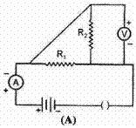  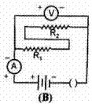  The observed readings of the ammeter and the voltmeter, by the two students are labelled as (i $​_{A}$ , V $​_{A}$ ) and (i $​_{B}$ , V $​_{B}$ ) respectively. The readings are likely to be related as  a) (i$​_{A}$ = i $​_{B}$ ); (V $​_{A}$ <V $​_{B}$ )  b) (i$​_{A}$ = i $​_{B}$ ); (V $​_{A}$ >V $​_{B}$ )  c) (i$​_{A}$ = i $​_{B}$ ); (V $​_{A}$ =V $​_{B}$ )  d) (i$​_{A}$ >V $​_{B}$ ); (i $​_{A}$ >V $​_{B}$ ) | [1]
5 | A student carries out an experiment and plots the V - I graph of three samples of nichrome wire with resistances R$​_{1}$ , R $​_{2}$ andR $​_{3}$ respectively figure. Which of the following is true? 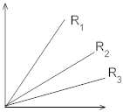  a) R$​_{3}$ > R $​_{2}$ > R $​_{1}$  b) R$​_{1}$ > R $​_{2}$ > R $​_{3}$  c) $\left(R∝\frac{1}{slope of V−I graph}\right)$  d) R$​_{3}$ = R $​_{2}$ = R $​_{1}$ | [1]
6 | The ammeters showing equal current in the following circuit are: 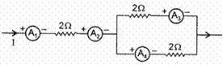  a) A$​_{3}$ and A $​_{4}$  b) A$​_{1}$ and A $​_{2}$  c) A$​_{2}$ , A $​_{3}$ and A $​_{4}$  d) A$​_{1}$ , A $​_{2}$ , A $​_{3}$ and A $​_{4}$ | [1]
7 | For the circuits A and B shown below in a given figure, the voltmeter readings would be 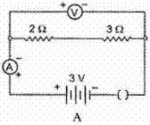  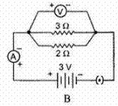  a) 0.6 V in circuit A and 2.5 V in circuit B  b) 0 V in both circuits  c) 5 V in both circuits  d) 0 V in circuit A and 3V in circuit B. | [1]
8 | The following circuit diagram shows the experimental set - up for the study of dependence of current on potential difference. which two circuit components are connected in series? 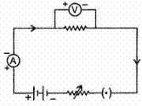  a) Resistor and voltmeter  b) Ammeter and rheostat  c) Ammeter and voltmeter  d) Battery and voltmeter | [1]
9 | For the experiment "to find the equivalent resistance of the two given resistors connected in parallel" the following circuit was drawn by a student. 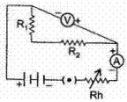  The teacher pointed out the possibility of the following faults : A. The ammeter was not correctly connected in the circuit. B. The voltmeter was not correctly connected in the circuit. C. The resistors R $​_{1}$ and R $​_{2}$ were not correctly connected in parallel. D. The rheostat and the key were not correctly connected in the circuit. The two faults pointed out correctly by the teacher, are  a) B and C  b) D and A  c) A and B  d) C and D | [1]
10 | To study the dependence of current (I) flowing on the applied potential difference (V) across a resistor, a student sets - up his apparatus as shown. He puts the sliding contact J, in the positions A, B and C, one by one and notes the three readings of the voltmeter as V$​_{A}$ , V $​_{B,}$ V $​_{C}$ and that of the ammeter as I $​_{A}$ , I $​_{B}$ , I $​_{C.}$ 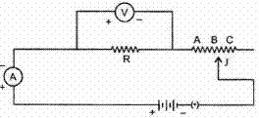  He would observe that  a) V$​_{A}$ > V $​_{B}$ > V $​_{C}$ but I $​_{A}$ > I $​_{B}$ > I $​_{C}$  b) V$​_{A}$ = V $​_{B}$ = V $​_{C}$ but I $​_{A}$ ≠ I $​_{B}$ ≠ I $​_{C}$  c) V$​_{A}$ ≠ V $​_{B}$ ≠ V $​_{C}$ but I $​_{A}$ = I $​_{B}$ = I $​_{C}$  d) V$​_{A}$ = V $​_{B}$ = V $​_{C}$ but I $​_{A}$ < I $​_{B}$ < I $​_{C}$ | [1]
11 | In the circuit diagram given below, the current flowing across 5 ohm resistor is 1 amp. The current flowing through the other two resistors: 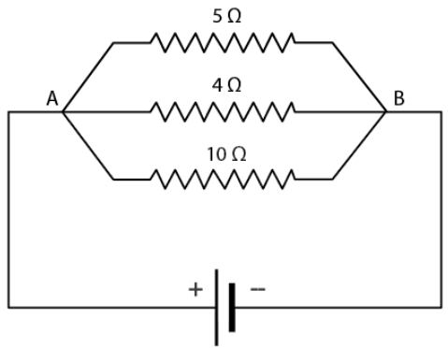  a) 1.25 amp  b) None of these  c) 0.5 amp  d) 0.4 amp | [1]
12 | Two resistances are connected in series as shown in the diagram. The potential difference across 12$Ω$ resistor will be: 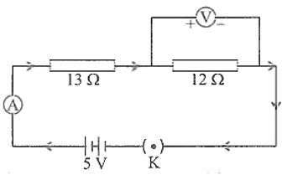  a) 2.4 V  b) 6 V  c) 12 V  d) 2.8 V | [1]
13 | A student draws the following circuit diagram for the experiment on studying the dependence of current (I) on p.d. (V) across a resistor. The parts labeled X, Y and Z, in this diagram are, respectively, 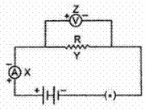  a) a milliammeter, a resistor and a voltmeter  b) a resistor, a voltmeter and a milliammeter  c) a voltmeter, a resistor and a milliammeter  d) a resistor, a milliammeter and a voltmeter | [1]
14 | A student sets up her circuit, for finding the equivalent resistance of a series combination of two given resistors R$​_{1}$ and R $​_{2}$ , in the manner as shown. She did not obtain the correct results in her experiment because of a mistake in her circuit. This mistake can be corrected by shifting the 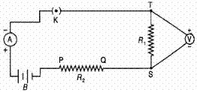  a) ammeter and connecting it between K and T  b) ammeter and connecting it across P and Q  c) voltmeter and connecting it across T and P with correct polarity  d) voltmeter and connecting it across P and Q | [1]
15 | Circuit I : ammeter reads current i$​_{1}$ and voltmeter reads V $​_{1}$ Circuit II : ammeter reads current i $​_{2}$ and voltmeter reads V $​_{2}$ 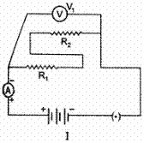  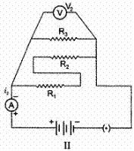  The relationship between the readings is  a) i$​_{1}$ < i $​_{2}$ ; V $​_{1}$ < V $​_{2}$  b) i$​_{1}$ > i $​_{2}$ ; V $​_{1}$ > V $​_{2}$  c) i$​_{1}$ < i $​_{2}$ ; V $​_{1}$ = V $​_{2}$  d) i$​_{1}$ > i $​_{2}$ ; V $​_{1}$ = V $​_{2}$ | [1]
16 | Using the circuit given below, state which of the following statement is correct? 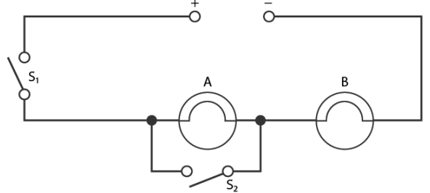  a) When S$​_{1}$ and S $​_{2}$ are closed, lamps A and B are lit  b) With S$​_{2}$ open and S $​_{1}$ closed A and B are lit  c) With S$​_{1}$ open and S $​_{2}$ closed, A is lit and B is not lit  d) With S$​_{1}$ closed and S $​_{2}$ open, lamp A remains lit even if lamp B gets fused | [1]
17 | Out of the two circuits shown here, the two resistors R$​_{1}$ and R $​_{2}$ have been correctly connected in series in 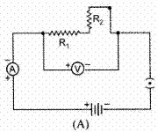  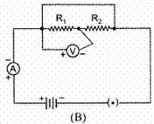  a) circuit A only  b) circuit B only  c) neither of the two circuits  d) both circuits A and B | [1]
18 | For the two circuits I and II shown below, the voltmeter readings would be 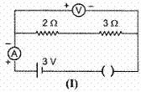  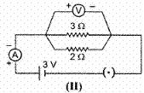  a) 3 V in circuit I and 0 V in circuit II  b) 0 V in circuit I and 3V in circuit II  c) 3 V in both the circuits  d) 0 V in circuit I and 2V in circuit II | [1]
19 | The rest positions of the needles in a Milliammeter and Voltmeter when not being used in a circuit are as shown in the figure. The ’zero error’ and ’least count’ of these two instruments are : 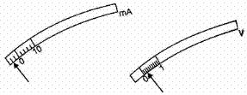  a) ( - 4 mA, +0.2 V) and (2 mA, 0.2 V) respectively  b) ( - 4 mA, +0.2 V) and (1 mA, 0.1 V) respectively  c) (+4 mA, - 0.2 V) and (2 mA, 0.2 V) respectively  d) (+4 mA, - 0.2 V) and (1 mA, 0.1 V) respectively | [1]
20 | To determine the equivalent resistance of a series combination of two resistors R$​_{1}$ and R $​_{2}$ , a student arranges the following set up : 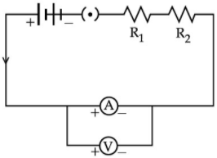  Which one of the following statements will be true for this circuit? It gives :  a) correct reading for potential difference V but incorrect reading for current I.  b) correct reading for current I but incorrect reading for potential difference V.  c) correct readings for both I and V  d) incorrect reading for current I as well as potential difference V. | [1]
21 | When performing the experiment on Ohm’s law noted the milliammeter reading and voltmeter reading. From the obtained readings, the value of resistance calculated by him will be 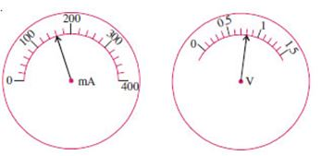  a) 5 Ω  b) 0.005 Ω  c) 0.5 Ω  d) 0.05 Ω | [1]
22 | A student plots V - I graphs for three samples of nichrome wire with resistances R$​_{1}$ , R $​_{2}$ and R $​_{3}$ . Choose from the following statement that holds true for this graph. 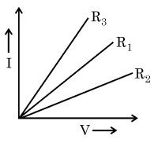  a) R$​_{2}$ > R $​_{1}$ > R $​_{3}$  b) R$​_{1}$ > R $​_{2}$ > R $​_{3}$  c) R$​_{1}$ = R $​_{2}$ = R $​_{3}$  d) R$​_{3}$ > R $​_{2}$ > R $​_{1}$ | [1]
23 | The only correct statement for the following electric is : 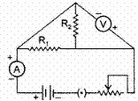  a) The Resistors R$​_{1}$ and R $​_{2}$ have been correctly connected in series.  b) The Resistors R$​_{1}$ and R $​_{2}$ have been correctly connected in parallel.  c) The Ammeter has been correctly connected in the circuit.  d) The Voltmeter has been correctly connected in the circuit. | [1]
24 | Three resistors are shown in the figure. The resistance of the combination is : 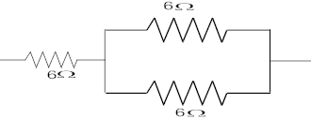  a) $9 Ω$  b) $6 Ω$  c) $7 Ω$  d) $3 Ω$ | [1]
25 | For the circuits shown in figures I and II, the voltmeter reading would be 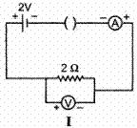  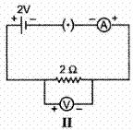  a) 2 V in both circuits  b) 0 V in circuit I and 2 V in circuit II  c) 2 V in circuits I and 0 V in circuit II  d) 0 V in both circuits | [1]
26 | Two students (A) and (B) connect their two given resistors R$​_{1}$ and R $​_{2}$ in the manners shown below : 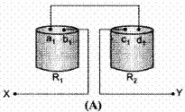  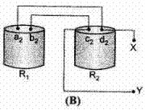  Student (A) connects the terminal marked (b $​_{1}$ ) and (c $​_{1}$ ) while student (B) connects the terminals marked (d $​_{2}$ ) and (c $​_{2}$ ) in their respective circuits at the points marked X and Y. 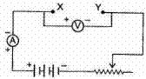  Which one of the following is correct in relation to above arrangements?  a) Student (A) will determine the equivalent resistance of the series combination while student (B) will determine the equivalent resistance of the parallel combination of the two resistors.  b) Both the students will determine the equivalent resistance of the parallel combination of the two resistors.  c) Both the students will determine the equivalent resistance of the series combination of the two resistors.  d) Student (A) will determine the equivalent resistance of the parallel combination while student (B) will determine the equivalent resistance of the series combination of the two resistors. | [1]
27 | Find the current in each resistor in the circuit shown below: 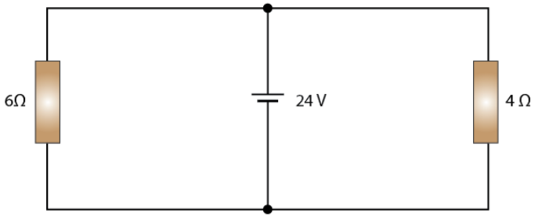  a) 6 amp  b) 1 amp  c) 5 amp  d) None of these | [1]
28 | In their experiment, on finding the equivalent resistance, of two resistors, connected in parallel, three students connected the voltmeter in their circuits, in the three ways X, Y, Z shown here. 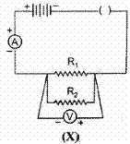  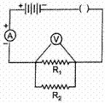  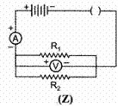  The voltmeter has been incorrectly connected in  a) All the three cases  b) case X only  c) case Z only  d) case Y only | [1]
29 | For determining the equivalent resistance of two resistors R$​_{1}$ and R $​_{2}$ connected in series, three student X, Y and Z set up their circuits as shown below. 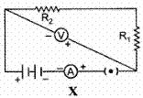  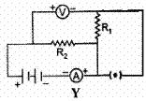  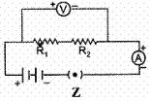  The correct set - up is that of  a) Student X only  b) Student Y only  c) Student X and Z  d) Student Z only | [1]
30 | The ammeter showing the maximum current is : 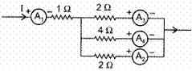  a) A$​_{1}$  b) A$​_{4}$  c) A$​_{3}$  d) A$​_{2}$ | [1]
31 | For carrying out the experiment, on finding the equivalent resistance of two resistors, connected in parallel, a student sets up his circuit as shown. The teacher checks it and tells him that his circuit has one or more of the following ’faults’. 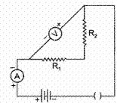  A. The resistors R $​_{1}$ and R $​_{2}$ have not been correctly connected in parallel. B. The voltmeter has not been correctly connected in the circuit. C. The ammeter and the key have not been correctly connected in the circuit. Out of these three, the actual fault in his circuit is/are  a) Only A  b) Only B  c) Both B and C  d) Both A and B | [1]
32 | In the following circuits (Figure), heat produced in the resistor or combination of resistors connected to a 12 V battery will be 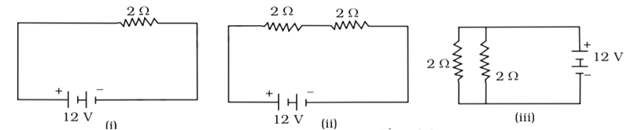  a) Minimum in case (i)  b) Same in all the cases  c) Maximum in case (iii)  d) Maximum in case (ii) | [1]
33 | Using the given circuit with ammeter and voltmeter answer the question. 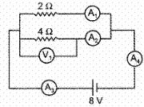  The current indicated by A $​_{3}$ is :  a) 6A  b) 2A  c) 1A  d) 4A | [1]
34 | To determine the equivalent resistance of two resistors when connected in series, a student arranged the circuit components as shown in the diagram. But he did not succeed to achieve the objective. 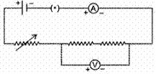  Which of the following mistakes has been committed by him in setting up the circuit ?  a) Terminals of ammeter are wrongly connected.  b) Terminals of voltmeter are wrongly connected.  c) Position of voltmeter is incorrect  d) Position of ammeter is incorrect | [1]
35 | The current flowing through a resistor and the potential difference developed across its ends are shown in the given diagrams : 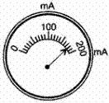  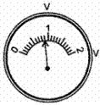  The value of resistance of the resistor is  a) 500 ohm  b) 0.5 ohm  c) 50 ohm  d) 5.0 ohm | [1]
36 | The diagram below shows part of a circuit: 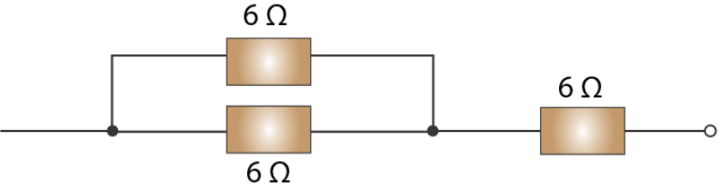  If this arrangement of three resistors was to be replaced by a single resistor, its resistance should be:  a) 9$Ω$  b) 18$Ω$  c) 4$Ω$  d) 6$Ω$ | [1]
37 | A student who wants to verify the equivalent resistance of two resistors R$​_{1}$ and R $​_{2}$ in series, attaches the end 1 and 2 of the voltmeter to three different pins of points in the given circuit. They are 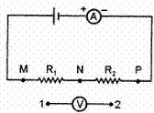  a)  [  (1, M), (2, N)  ]  ,  [  (1, N), (2, P)  ]  and  [  (1, M), (2, P)  ]  b)  [  (1, M), (2, N)  ]  ,  [  (1, N), (2, P)  ]  and  [  (1, N), (2, M)  ]  c)  [  (1, M), (2, N)  ]  ,  [  (1, P), (2, N)  ]  and  [  (1, N), (2, M)  ]  d)  [  (1, N), (2, P)  ]  ,  [  (P,1), (2, N)  ]  and  [  (1, N), (2, M)  ] | [1]
38 | Out of the four given circuits for studying the dependence of the current on the potential difference across a resistor, the circuit that has been correctly drawn, is circuit 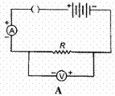  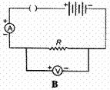  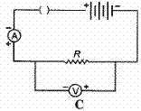  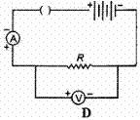  a) A  b) C  c) D  d) B | [1]
39 | A student found that when a resistance of 3$Ω$ was joined with 3 V battery as per figure shown below, the current flowing through it was 1 A. He then joined another resistance of 6 $Ω$ in parallel with 3 $Ω$ resistance. The reading in the ammeter will now be: 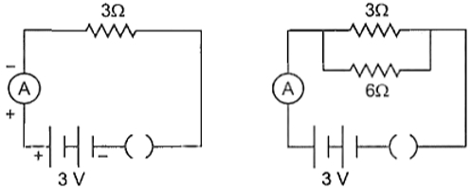  a) 9 A  b) 1 A  c) 6 A  d) 1.5 A | [1]
40 | Two students set up their circuits for finding the equivalent resistance of two resistors connected in parallel in two different ways as shown. 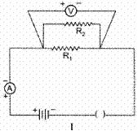  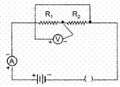  The circuits likely to be labelled as correct :  a) are neither of the two circuits  b) are both the circuits  c) is only circuit I  d) is only circuit II | [1]
41 | To determine the equivalent resistance of a series combination of two resistors R$​_{1}$ and R $​_{2}$ , a student arranges the following set - up :which one of the following statements will be true for this circuit ? 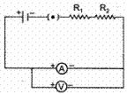  a) Incorrect reading for current I as well as potential difference V.  b) Correct reading for potential difference V but incorrect reading for current I  c) Correct reading for current I but incorrect reading for potential difference V.  d) Correct reading for both current I and potential difference V. | [1]
42 | For the two circuits (i) and (ii) shown below the voltmeter reading would be 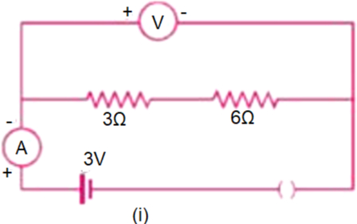  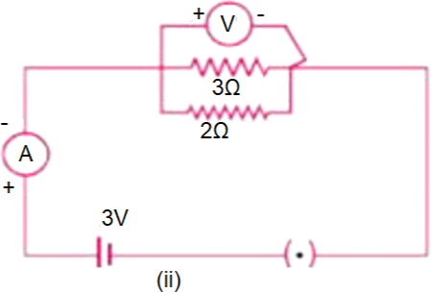  a) 0 V in case (i) and 2 V in case (ii)  b) 3 V in both the circuits  c) 3 V in case (i) and 0 V in case (ii)  d) 0 V in case (i) and 3 V in case (ii) | [1]
43 | In an experiment, to find the equivalent resistance of a series of combination of two resistors R$​_{1}$ and R $​_{2}$ a student used the circuit shown here. 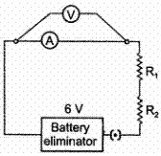  The circuit will give  a) correct reading for current I, but incorrect reading for voltage V  b) incorrect readings for both current I and voltage V  c) correct reading for voltage V, but incorrect reading for current I  d) correct reading for both current I and voltage V | [1]
44 | In the circuit shown below: 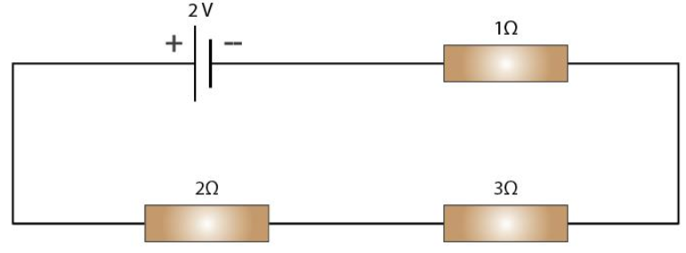  The potential difference across the 3 $Ω$ resistors is:  a) 2 V  b) $\frac{1}{9}$ V  c) $\frac{1}{2}$ V  d) 1 V | [1]
45 | The proper representation of the series combination of cells (Figure) obtaining maximum potential is 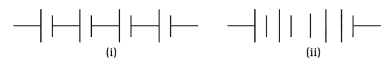  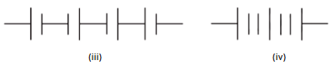  a) (i)  b) (iv)  c) (ii)  d) (iii) | [1]
46 | Four different measuring instruments are shown below. Out of these, the instrument that can be used for measuring current is/are the instruments labelled as 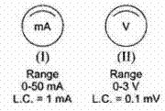  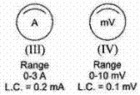  a) II and IV with IV more reliable of the two  b) II and III with II more reliable of the two  c) I and III with III more reliable of the two  d) I and IV with IV more reliable of the two | [1]
47 | A student set up an electric circuit shown here for finding the equivalent resistance of two resistors in series. In this circuit, the 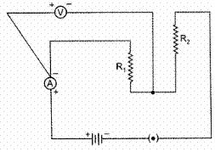  a) resistors, as well as the voltmeter, have been wrongly connected  b) resistors have been connected correctly but the voltmeter has been wrongly connected  c) resistors, as well as the ammeter, have been wrongly connected  d) resistors have been connected correctly but the ammeter has been wrongly connected | [1]
48 | In the experiment on finding the equivalent resistance of two resistors, connected in parallel, two students connected the ammeter in two different ways as shown in given circuits I and II. The ammeter has been correctly connected in 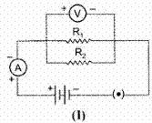  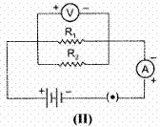  a) both the circuits (I) and (II)  b) circuit (II) only  c) circuit (I) only  d) neither of the two circuits. | [1]
49 | V – I graph for a metallic wire at two different temperatures T$​_{1}$ and T $​_{2}$ areshown in the following figure. Which of the two temperatures is higher? 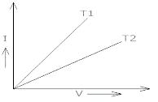  a) TemperatureT$​_{1}$  b) None of these  c) TemperatureT$​_{2}$  d) TemperatureT$​_{1}$ = TemperatureT $​_{2}$ | [1]
50 | The rest positions of the needles in a millimeter and voltmeter not in use are as shown in Fig a. when a student used these in his experiment, the readings of the needle are in the positions shown in Fig. B. The corrected values of current and voltage in the experiment are 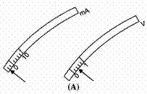  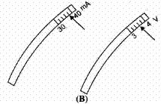  a) 34 mA and 4.0 V  b) 42 mA and 4.0 V  c) 34 mA and 3.2 V  d) 42 mA and 3.2 V | [1]
51 | Using the given circuit with ammeter and voltmeter answer the question.   The ammeters showing same reading are :  a) A$​_{3}$ , A $​_{4}$  b) A$​_{1}$ , A $​_{2}$  c) A$​_{1}$ , A $​_{3}$  d) A$​_{2}$ , A $​_{4}$ | [1]
52 | The current flowing through a resistor connected in an electrical circuit and the potential difference developed across its ends are shown in the given diagrams : 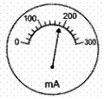  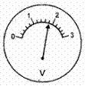  The value of resistance of the resistor in ohms is  a) 15  b) 25  c) 10  d) 20 | [1]
53 | For three circuits, shown here 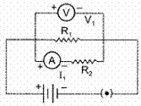  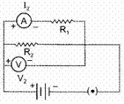  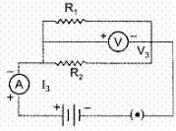  The same two resistors R $​_{1}$ and R $​_{2}$ have been connected in parallel in all the circuits but the voltmeter and the ammeter have been connected in three different positions. The relation between the three voltmeter and ammeter readings would be  a) V$​_{1}$ = V $​_{2}$ = V $​_{3}$ and I $​_{1}$ ≠ I $​_{2}$ ≠ I $​_{3}$  b) V$​_{1}$ ≠ V $​_{2}$ ≠ V $​_{3}$ and I $​_{1}$ = I $​_{2}$ = I $​_{3}$  c) V$​_{1}$ = V $​_{2}$ = V $​_{3}$ and I $​_{1}$ = I $​_{2}$ = I $​_{3}$  d) V$​_{1}$ ≠ V $​_{2}$ ≠ V $​_{3}$ and I $​_{1}$ ≠ I $​_{2}$ ≠ I $​_{3}$ | [1]
54 | A cell, a resistor, a key, and an ammeter are arranged as shown in the circuit diagrams of the figure. The current recorded in the ammeter will be 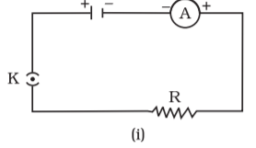  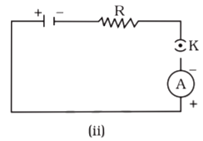  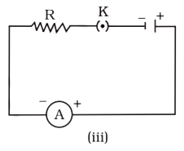  a) Maximum in (ii)  b) The same in all the cases  c) Maximum in (i)  d) Maximum in (iii) | [1]
55 | A student, using the same two resistors, battery, ammeter and voltmeter, sets up two circuits, connecting the two resistors, first in series and then in parallel. If the ammeter and voltmeter readings, in the two cases, are (I$​_{1}$ , I $​_{2}$ ) and (V $​_{1}$ , V $​_{2}$ ) respectively, he is likely to observe that 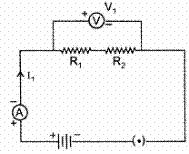  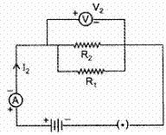  a) I$​_{1}$ = I $​_{2}$ but V $​_{1}$ = V $​_{2}$  b) I$​_{1}$ > I $​_{2}$ but V $​_{1}$ = V $​_{2}$  c) I$​_{1}$ = I $​_{2}$ but V $​_{1}$ ≠ V $​_{2}$  d) I$​_{1}$ < I $​_{2}$ but V $​_{1}$ = V $​_{2}$ | [1]
56 | In the experiment on finding the equivalent resistance of two resistors, connected in series, the ammeter is correctly connected in: 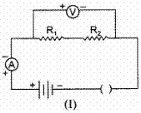  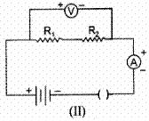  a) neither of the two circuits.  b) circuit (II) only  c) circuit (I) only  d) both circuits (I) and (II) | [1]
57 | The given diagram shows the milliammeter reading connected in a circuit : 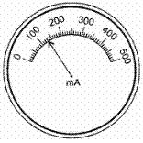  The value of current flowing in the circuit is  a) 103 mA  b) 160 mA  c) 100.3 mA  d) 130 mA | [1]
58 | A student sets up the circuit shown here for finding the equivalent resistance of two resistors, connected in series. 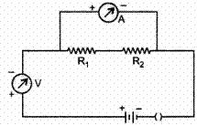  a) the two resistors, the voltmeter and the ammeter have all been connected correctly  b) the two resistors have been connected correctly but both the voltmeter and the ammeter have not been connected correctly.  c) the two resistors and the ammeter have been connected correctly, but the voltmeter has not been connected correctly.  d) the two resistors and the voltmeter have been connected correctly but the ammeter has not been connected correctly. | [1]
59 | Three batteries shown in the circuit has the emf of 2 V, 3 V, and 5 V correspondingly with an internal resistance of 1$Ω$ . The external resistance of the circuit is 2 $Ω$ . Determine the value of the current I. 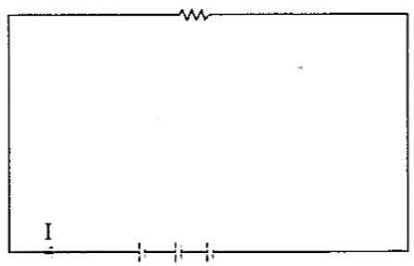  a) 1.5 A  b) 2.0 A  c) 2.5 A  d) 3.1 A | [1]
60 | From the shown figure, XY has a resistance of 35$Ω$ , the potential difference across XY will be equal to ________. 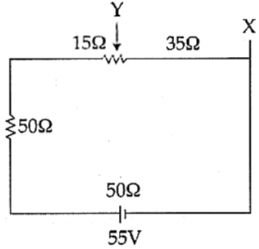  a) 13.44 V  b) 12.83 V  c) 10.01 V  d) 14.67 V | [1]
61 | The correct way of connecting the ammeter and voltmeter with a series combination of two resistors in a circuit for finding their equivalent resistance, is shown in diagram 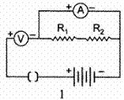  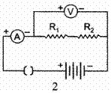  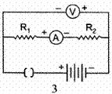  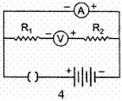  a) 4  b) 2  c) 1  d) 3 | [1]
62 | A student performs an experiment on studying the dependence of the current (I) flowing through a conductor on the potential difference (V) applied across it by setting up his circuit as shown. He records four values of ’I’ by keeping the sliding contact J, in the positions K, L, M and N, one by one. The corresponding points on his V - I graph are labelled as P$​_{1}$ , P $​_{2}$ , P $​_{3}$ and P $​_{4}$ . The point P $​_{3}$ , would corresponding to the case when the sliding contact, J, is in the position 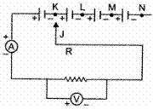  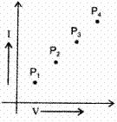  a) N  b) L  c) K  d) M | [1]
63 | Observe the figures K, L, M, N given below :The correct way of connecting the ammeter and voltmeter with a series combination of two resistors in a circuit for finding their equivalent resistance, is shown in diagram : 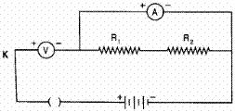  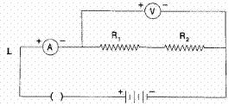  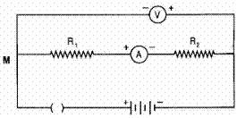  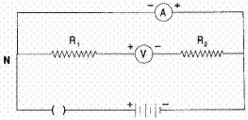  a) L  b) N  c) K  d) M | [1]
64 | The value of resistance marked on the two coils R$​_{1}$ and R $​_{2}$ are found to be correct. A student connects the given resistors in the following manner : 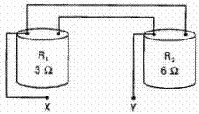  He then connects the terminals marked X and Y above to the terminals marked X and Y in the circuit given below : 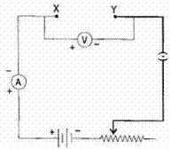  The average value of the ratio $\frac{V}{I}$ in the observations recorded in the above circuit would be :  a) less than 3Ω  b) more than 6Ω  c) equal to 9Ω  d) between 3Ω and 6 Ω | [1]
65 | Following circuits were drawn by four students, to determine the equivalent resistance of two resistors when connected in parallel. The correct circuit is drawn by the student. 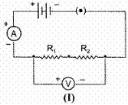  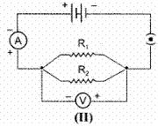  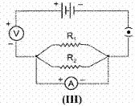  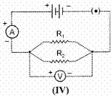  a) III  b) II  c) I  d) IV | [1]
66 | For the circuits A and B shown below, find thevoltmeter readings would be 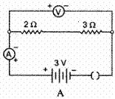  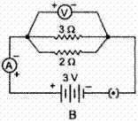  a) 5 V in both circuits  b) 0 V in both circuits  c) 0 V in circuit A and 3 V in circuit B  d) 0.6 V in circuit A and 2.5 V in circuit B | [1]
67 | To study the dependence of current (I) on the potential difference (V) across a resistor R, two students used the two set ups shown in Figure A and B respectively. They kept the contact point J in four different positions, marked (i), (ii), (iii) and (iv) in the two figures. 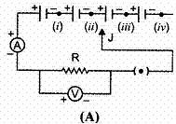  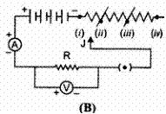  For the two students, the ammeter and voltmeters readings will be maximum when the contact J is in the position  a) (iv) in set up A and (i) in set up B  b) (i) in both the set ups  c) (iv) in both the set ups  d) (i) in set up A and (iv) in set up B | [1]
68 | Which of the following resistor arrangement, A or B, has the lower combined resistance? 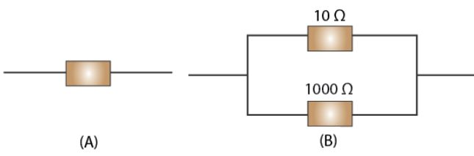  a) 9.9  b) None of these  c) 9.0  d) 9.5 | [1]
69 | The only correct statement for the two circuits (X) and (Y) shown below is : 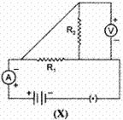  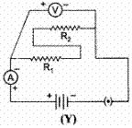  a) The resistors R$​_{1}$ and R $​_{2}$ have been connected in parallel in both the circuits.  b) The resistors R$​_{1}$ and R $​_{2}$ have been connected in series in both the circuits.  c) In the circuit (X) the resistors have been connected in parallel whereas these are connected in series in circuit (Y)  d) In the circuit (X) the resistors R$​_{1}$ and R $​_{2}$ are connected in series while these are connected in parallel in circuit (Y). | [1]
70 | Two resistors R$​_{1}$ and R $​_{2}$ have their terminals marked as (a), (b), (c) and (d) as shown. A student connects these terminals to one another in two different ways shown below : 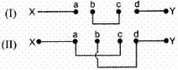  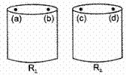  The equivalent resistance between the points X and Y in the two cases, are measured to be R’ and R” respectively. We can then say that  a) Both R’ and R" are equivalent to the parallel combination of R$​_{1}$ and R $​_{2}$  b) R’ is equivalent to the parallel combination of R$​_{1}$ and R $​_{2}$ and R" is equivalent to the series combination of R $​_{1}$ and R $​_{2}$  c) R’ is equivalent to the series combination of R$​_{1}$ and R $​_{2}$ , R” is equivalent to the parallel combination of R $​_{1}$ and R $​_{2}$  d) Both R’ and R" are equivalent to the series combination of R$​_{1}$ and R $​_{2}$ | [1]
71 | While doing their experiment, on finding the equivalent resistance, of two resistor connected in series, three students A, B, C set up their circuits as shown below : 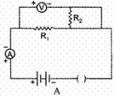  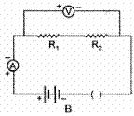  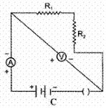  The correct set up is that of  a) Student B and C  b) Student A and B  c) Student B, C and A  d) Student C and A | [1]
72 | For the circuit arrangement, show below, the student would observe 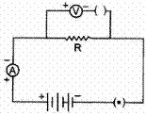  a) some reading in the voltmeter but no reading in the ammeter  b) no reading in either the ammeter or the voltmeter  c) some reading in the ammeter but no reading in the voltmeter  d) some reading in both the ammeter and the voltmeter | [1]
73 | In the experiments on finding the equivalent resistance of two resistors, connected in parallel, three students connected the voltmeter in their circuits, in the three ways, X, Y and Z shown here. 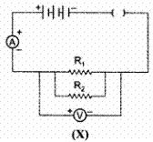  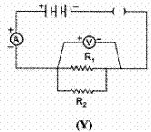  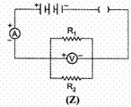  The voltmeter has been correctly connected in  a) cases Z and X only  b) cases X and Y only  c) cases Y and Z only  d) all X, Y and Z cases | [1]
74 | The values of resistance marked on the coils R$​_{1}$ and R $​_{2}$ are found to be correct. A student connects the given resistors in the following manner. 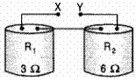  He then connects the terminals marked X and Y above to the terminals marked X and Y in the circuit. 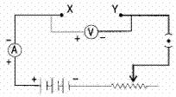  The average value of the ratio $\frac{V}{I}$ in the observations recorded in the circuit would be :  a) 2 Ω  b) 6 Ω  c) 9 Ω  d) 3 Ω | [1]
75 | Which of the circuit components in the following circuit diagram are connected in parallel ? 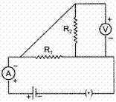  a) R$​_{1}$ and V only  b) R$​_{1}$ and R $​_{2}$ only  c) R$​_{1}$ , R $​_{2}$ and V  d) R$​_{2}$ and V only | [1]

